1. Search “fujifilm support drivers” in Google Search.
2. Click on Support & Drivers link:Graphical user interface, text

   Description automatically generated
3. Type “MM” , then select “Multi-Model Printer Driver 2”, and search.

1. Click Download button to download exe file.

1. After download, click on it to Run.

1. Click Accept agreement.

1. Go to “Add Printer and Scanner”, and Click on “Add device”.

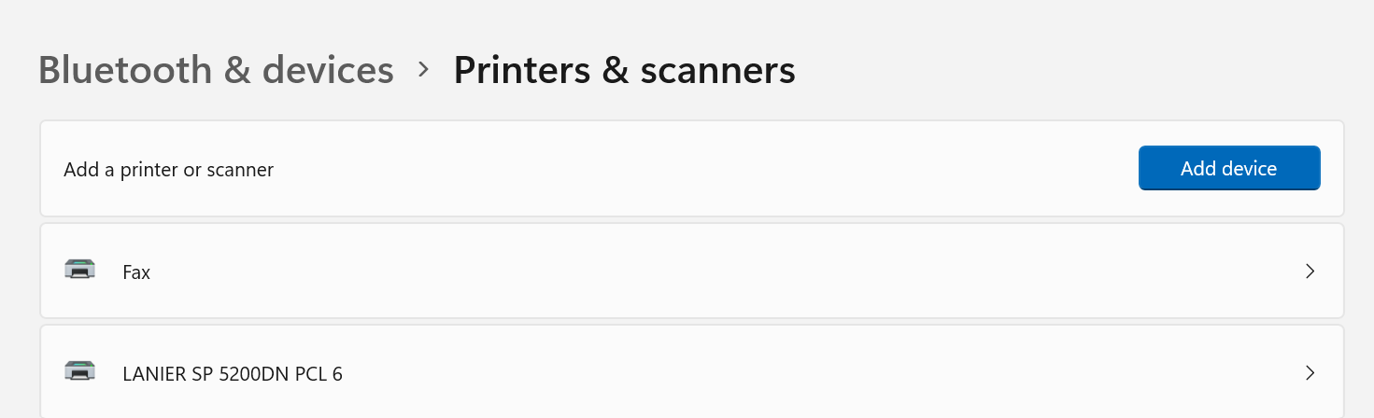

1. Click on “Add Manually”

1. Add Printer

1. Choose the port. Graphical user interface

   Description automatically generated
2. Click on “Have Disk”Graphical user interface, application

   Description automatically generated
3. Navigate to the downloaded inf file

1. Click on Next to Install.

1. Choose “Do not share this printer”

1. Done setup Graphical user interface, text, application, email

   Description automatically generated

16. Note: Set the printer properties – preference – 2 sided print.

