MAXCONNECT
Online Credit Card Processing Service Manual
HTML Link Method One-time Billing
- Before introduction

  - Regarding the technical manual
This is a technical manual for MAXCONNECT Credit Card Processing Service.
  - Note
This manual can only be provided for the clients who are willing to use MAXCONNECT Credit Card Processing Service. It is strictly prohibited for this manual to be disclosed to unauthorized third parties without permission from MAXCONNECT. And it is also strictly prohibited for this manual to be copied without permission from MAXCONNECT.

  - Enquiries
MAXCONNECT Customer Support
TEL +65-6323-4048
EMAL sales@max-c-e.com
- System details

  - HTML Link Method
In HTML Link Method, you simply need to send customer credit card information to the system by HTTP-POST format. Then the system will display a SSL payment form in which customers enter their credit card information. The system takes care of the rest of the process. You simply need to set up all the required parameters and access to the page. Then, a payment form will be displayed for the customer to enter his credit card information. If one or more of the required parameters are missing, an error screen will be displayed. So please make sure that all the required parameters are sent to the system. In this method, you do not need to build a SSL server yourself. You can introduce online credit card payment very easily.

  - Parameter
In addition to the required parameters specified by MAXCONNECT, you can add whatever parameters you would like to add. The system will simply return all the parameters it received to your server.
    - You cannot use the same parameter name as used by MAXCONNECT.
    - The system doesn’t store any other parameters than the ones used by MAXCONNECT.

  - Kick system
The system will return (kick back) the result by HTML GET method to the URL specified by you as soon as the processing completes or fails. The followings are the processing types of the result.
- One-time Billing Process

    - Return button
The system sends the transaction result to the URL specified by you by POST method when ‘Back’ button on the settlement input screen or on the settlement completion screen. (‘Back’ button on the settlement input button means settlement failure while the same button on the settlement completion screen means settlement success)

* There is no gurantee that users press the ‘Back’ button as they could simply close the browser. We don’t recommend to use the data sent after ‘Back’ button is pressed to know if the transaction has failed or succeeded. For this purpus, please use the Kick process as
* You need to give our gateway system an access permission to the URL to which user is redirected after ‘Back’ button is pressed. (a reading permission. It differs with the type of the server you use how to configure it)

Example: in case that the ‘Back’ URL is http://www.xxx.net/cgi-bin/get_result.cgi
<form action="http://www.xxx.net/cgi-bin/get_result.cgi" method="post">
<input type="hidden" name="SiteId" value="99999999" >
<input type="hidden" name="CustomerId" value="TEST">
<input type="hidden" name="Amount" value="10">
<input type="hidden" name="Result" value="OK">
<input type="submit" value="戻る" >
</form>

    - Kick system
The system will return (kick back) the result by HTML GET method to the URL specified by you as soon as the processing completes or fails. The followings are the processing types of the result.
- One-time Billing Process

  - Introduction of the system
You don’t need to have any special software or equipments. You just need to add a simple HTML code for a payment form to your web site.

- One-time Billing

  - One-time Billing
This is called a one-time billing because the system processes each transaction every time one occurs. Installment or revolving payment is not available for this service.

  - Quick Charge
By storing the customer’s credit card information on our server, they don’t need to reenter the same credit card information every time they make payments.

- How to introduce

  - One-time Billing
①Screen（Default）
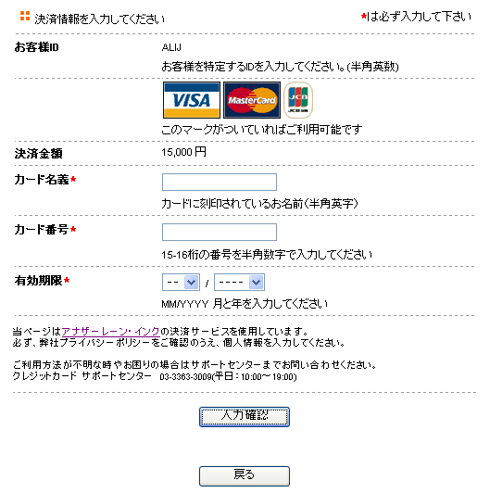

②Where to send
Please send all the necessary information to the following URL
【URL】 https://mc-credit.com.sg/service/credit/input.html

③Parameter to be sent
Parameter ID | Contents | Type |  | Digits | Required?
SiteId | ID assigned by MAXCONNECT. | Numeric |  | 8 | ○
SitePass | Password assigned by MAXCONNECT.. | Alphanumeric |  | 8 | ○
Amount | Please send settlement amount (first payment amount)  ※Maximum digits for JPY is 8.  ※maximum digits for USD is 8 plus 2 for decimals. | Numeric |  | 10 | ○
CustomerId | Customer ID | Alphanumeric |  | 50
CustomerPass | Customer Password | Alphanumeric |  | 50
itemId | Please send the product ID. By adding other related product information using ”:” or ”,”, you can display it on the payment screen.  Example 1  itemId=ITEM01:1unit:1000yen  Example 2  itemId=ITEM01:1unit:1000yen,ITEM02:2unit:2000yen  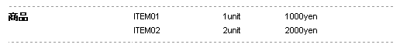 | Alphanumeric |  | 100
Zip | Zip code | Numeric |  | 10
capital | State or prefecture name  Ex. Tokyo | Alphanumeric |  | 4
adr1 | Address1 | Alphanumeric | 100
adr2 | Address2 | Alphanumeric |  | 100
Name | Name | Alphanumeric |  | 25
Tel | Telephone number | Numeric |  | 30
Mail | Email ( Confirmation email will be sent to this email address after the transaction is approved) | Alphanumeric |  | 100
Note | Return the comments entered by the customer. | Alphanumeric |  | 100
TransactionId | Transaction ID (If it is not specified, the system automatically issues a unique ID to the transaction) | Alphanumeric |  | 50
ipaddr | Card holder’s IP address | Alphanumeric |  | 15
country | The ISO 3166 two (2) character code for the country of the cardholder’s billing address. | Alphanumeric |  | 2
language | Return the language used in the Screen.  Japanese=ja, English=en ,Korean=ko, Chinese=zh, Germany=de, Spanish=es, French=fr, Italian=it, Portuguese=pt  Normally it is automatically set according to the language used in the browser  If the language set to the browser is not supported by the system, English is automatically chosen.  If no language is set to the browser, Japanese is chosen.  If mobile browser is used and this parameter is not specified, Japanese is chosen. | Alphanumeric |  | 2
Others | You can add whatever parameters you would like to add to the parameters that are returned after the transaction is approved. The above and following parameters cannot be used.  cardName,cardNo,cardYear,cardMonth,cvv2

■Sample
<form action="https://mc-credit.com.sg/service/credit/input.html" method=”post”>
<input type="hidden" name="SiteId" value="99999999">
<input type="hidden" name="SitePass" value="maxce">
<input type="hidden" name="CustomerId" value="test_user">
<input type="hidden" name="CustomerPass" value="password">
<input type="hidden" name="Amount" value="1">
<input type="submit">
</form>

④Output (Back or Kick) parameter
Parameter ID | Contents | Type | Digits
SiteId | ID assigned by MAXCONNECT.. | Numeric | 8
Amount | Return the processing result for the first payment.。  ※Maximum digits for JPY is 8..  ※Maximum digits for USD is 8 plus 2 for decimals. | Numeric | 10
CustomerId | Return the ID of the customer who wishes to make the payment. | Alphanumeric | 50
CustomerPass | Return the password of the customer who wishes to make the payment. | Alphanumeric | 50
itemId | Please send the product ID. By adding other related product information using ”:” or ”,”, you can display the details of the product on the payment screen.  Example 1  itemId=ITEM01:1unit:1000yen  Example 2  itemId=ITEM01:1unit:1000yen,ITEM02:2unit:2000yen | Alphanumeric | 100
Zip | Zip number | Numeric | 10
capital | State or prefecture name.  Ex. Tokyo" | Alphanumeric | 4
adr1 | Address1 | Alphanumeric | 100
adr2 | Address2 | Alphanumeric | 100
Name | Name | Alphanumeric | 25
Tel | Telephone number | Numeric | 30
Mail | Email address ( Confirmation email will be sent to this email address after the transaction is approved) | Alphanumeric | 100
Note | Return the comments entered by the customer. | Alphanumeric | 100
TransactionId | Transaction ID (If it is not specified, the system automatically issues a unique ID to the transaction) | Alphanumeric | 50
language | Return the language used in the Screen.  Japanese=ja, English=en ,Korean=ko ,Chinese=zh  Normally it is automatically set according to the language used in the browser | Alphanumeric | 2
country | The ISO 3166 two (2) character code for the country of the cardholder’s billing address. | Alphanumeric | 2
Others | You can add whatever parameters you would like to add to the parameters that are returned after the transaction is approved. The above and following parameters cannot be used.  cardName,cardNo,cardYear,cardMonth,cvv2
Result | Return the result of the settlement.  OK：Approved  NG：Failed | Alphanumeric | 2

