Change Request Information -- Completed by requester for New status CR No: UK-CR-044
Project ID: | eCosway |  |  | Request Type: | Addendum/Change/New
Requested By: | Ong Pei Ling |  |  | Request Date: |  | 09/01/2012
Logged By: | Shida |  |  | CR from Operation: |  | CR0633_060112
Received By: |  |  |  | Received Date:
Requester Priority:
Affected Component(s): |  | Control Center  UK Online Office  UK IBO Registration Form  UK HSBC Bank file (UK-CR-024) |  |  |  | Version/ Date:
Short Description: |  | Add Building Society Option as Payment Type in UK Bank Detail
Description of Change: |  | Add ‘Building Society’ in Payment type option and ‘Building society reference No.’.  There are 2 options for UK member to remit their profit through bank file.  If member choose Building Society as payment type, ‘Building society reference No.’ is compulsory.  To add 2 new fields in US database to store payment type and building society ref no.  - SHOPPER_BANK_DETAIL.ACTYPE for payment type  - SHOPPER_BANK_DETAIL.BSREFNO for Building Society Ref no.  Attachment 1: UK Online Registration form  Attachment 2: UK Online Office: My Profile >>Banking Details  Attachment 3: Control Center
  Payment type | Indicator
  Bank | B
  Building Society (new add) | P
Benefit of
Change Request:
Issues/Concerns with Request:
Other Affected Areas:
Need Resolution by (Date):

Tracking/Impact Analysis Information- Completed by Project Team for Assign and Open status
Change Request Report No: |  | Assigned Date:
Assigned To: |  | Open Date:
Proposed Solution:
Impact of Request:
Estimated Resolution Time (man day): |  |  | Estimated Resolution Date:

Attachment 1

UK Online Registration form: https://www.ecosway.com/ukstore/uk/BoRegistration4_uk.jsp?secureSite=Y#myId

Step 4 : Starter Kit, Bank Account Details & Payment Summary

Bank Account Details
(Optional at this stage – This section is meant for your profit payout purposes, . You can fill complete this section from your Online Office at any time after you have registered and received your Online Office access details in our email to you)

Bonuses and commissions payable under the Profit Plan will be paid directly into your bank account. Please check and amend the details below:

Name on Account: (System default same as Registration form)
Note to TPM: Newly added
Radio button for selection
Bank Name: (Max 50 Characters)

Payment Type:   Normal Bank Account
  Building Society
Note to TPM:
Currently system set as max 9 digit, as per confirmation with Janelle, it’s only 8 digits, please amend.

Bank Branch Address including Town/City: (Max 50 Characters)

Account No: (8 digit)

Sort Code: (1st Field fixed 2 numeric)-(2nd field fixed 2 numeric)-(3rd field fixed 2 numeric)

Building Society Reference No. or Payee’s Name: (Minimum 4,Maximum 18 characters alphanumeric)
(Max. 18 alphanumeric characters)

Note to TPM: Newly added
- Alphanumeric inclusive spacing (e.g. Elizabeth Kathy Bl)
- If payment type = Bank, ‘Building Society Reference No. or Payee’s Name’ is disable field.
- If payment type = Building Society, ‘Building Society Reference No. or Payee’s Name’ is compulsory field.

Attachment 2

UK Online Office: My Profile >>Banking Details

Under View My Profile Details page: http://www.ecosway.com/ukstore/uk/MemberProfileDisplay_uk.jsp#
- To add an ‘Payment Type’ field at Banking details, to detect either 1) Normal Bank Account or 2) Building Society based on the choice of selection by IBOs.
Remarks: Currently we do not have other account type besides ‘Normal Bank Account’ hence for existing members that had filled up the banking details, kindly please default the field as Normal Bank Account.
- The Building Society Reference No. field will not shown if the type of account is other than Building Society.

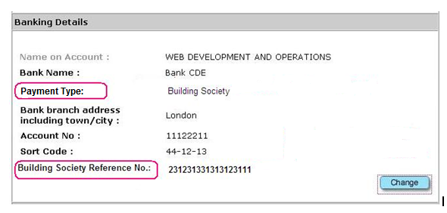

Under Edit/ Change My Profile Details page: http://www.ecosway.com/ukstore/uk/MemberProfileBankDetails_uk.jsp

- If members do not fill in the bank account details during registration, from edit/change page, system can allow members to choose the account type and fill in the Building Society Reference No. same as per propose to show at Registration form.
- If members would like to make changes on the existing banking info.

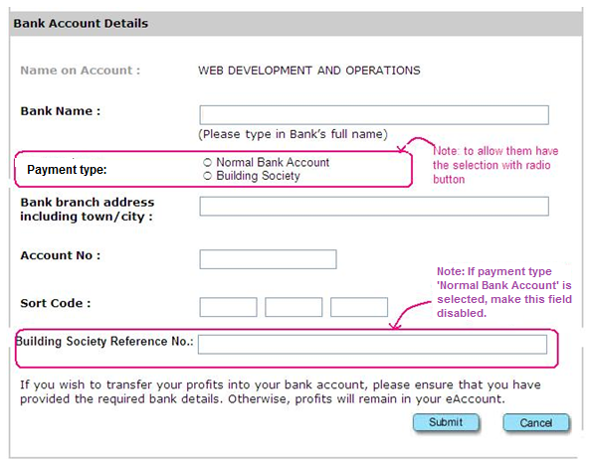

Attachment 3 – Control Center

Top of Form
Top of Form
Bank Account Details
Please provide an existing Bank Account number in order for us to remit payments owing to you.Remittance will not be done if there is no valid bank number.
Bank Account Holder Name
Bank Account Number
Account Type | Checking Account  Savings Account
 | (Bank Account Number is restricted to 10-12 digits in Hong Kong Bank.)
Payment Type | Normal Bank Account  Newly add  Building Society
Bank Name
 | (Please input the full name of the Bank)
Bank Code
 | Refer to Bank Code Guideline)
Branch/BSB
 | (Official branch name for the selected bank)
Sub Branch
Address
Zip/Postcode
City
State
Country
Sort Code
Building Society Ref No |  | Newly add
Profit Payment Method : | CHECK/PROFIT REDEMPTION VOUCHER  Check here if you would prefer to have your profits mailed to you by cheque.(This option is only available to residents of Malaysia, Singapore, Hong Kong or Brunei)  eACCOUNT/BANK ACCOUNT

Bottom of Form

