ECOSPROXY PROJECT
SOLUTION DESIGN DOCUMENT

Copyright
© ECosway AB 2009 - All Rights Reserved
Disclaimer
No part of this document may be reproduced in any form without the written permission of the copyright owner.
The contents of this document are subject to revision without notice due to continued progress in methodology, design and manufacturing. ECosway shall have no liability for any error or damage of any kind resulting from the use of this document.

Table of Contents
1 Introduction 4
1.1 Purpose 4
1.2 Revision History 4
1.3 Reference 4
2 SOLUTION OVERVIEW 5
2.1 Description 5
3 SCOPE OF WORK 7
3.1 Inclusion 7
3.2 Exclusion 8
3.3 Assumption 8
4 Hardware Specification 9
4.1 Application Server 9
5 Software Specification 10
5.1 Application/Database Server 10
6 Application Deployment 11
6.1 Application Server 11
7 System Integration 12
8 Network Design 13
8.1 Server Details 13
8.2 Firewall Rules - External System, Production Environment 13
9 MLM Union Database Schema 13

Introduction

Purpose
The purpose of this document is to detail the solution design information of the eCosProxy project.

Revision History

Change  Date | Author’s Name | Revision  No. | Change Summary
11/01/2010 | Kwan Chooi Mey | PA1 | - Initial draft created
24/02/2010 | Kwan Chooi Mey | PA2 | - Added in section 9 – database schema.

Reference

SOLUTION OVERVIEW

Description

POS System is a client based Point Of Sales System to be used by eCosway stockiest in Korea.
POS System need to register all the sales transaction made in eCosway stockiest to the MLM Union, to get the sales registration number, as a consumer reference number to be printed in invoice upon transaction is made.

In order to decouple the dependency of POS systems towards MLM Union Sales Report Program, eCosProxy will act as a proxy between POS System and Sales Report Program. The eCosProxy will provide the interface services to POS system, to register the sales to MLM Union by obtaining the sales registration number accordingly.
This document will describe the Integration Interface of POS System with MLM Union Sales Report Program via the eCosProxy, which provides Web Services through SOAP protocol.
Below architecture is designed with the communication protocol:

- Communication protocol between POS System and EcosProxy is via SOAP-HTTP.
- Communication protocol between EcosProxy and Sales Report Program is via JDBC Connection.

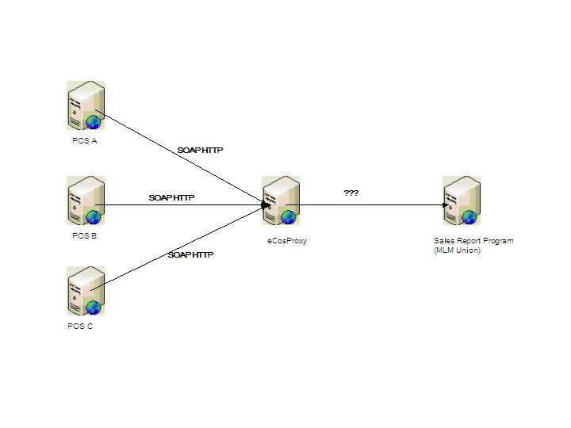
Figure 2-1: Integration Architecture between POS System and Sales Report Program

SCOPE OF WORK

Inclusion
The scope of work for eCosProxy project shall include the following activities:
- Software installation
      - Jboss Application Server 4.2.2
      - JbossWS Apache-cxf 3.2.2 GA
      - JRE version 1.5
- Requirement Gathering, Analysis, Design, Develop, Test and Deploy eCosProxy Web Services.
- Integrate eCosProxy to the following external system:
      - Sales Report Program provided by MLM Union
- Support Integration of eCosProxy by the following external system:
      - Cosway POS System
- System Performance/Load Test
      - A black box approach performance load test will be conducted on eCosProxy web service.
      - Performance measurement reporting is limited to the front end (client) only.
      - For the Front end, client load test tool (Jmeter) will be used.
      - For the Back end connection, receiving modules or Simulator will be developed to simulate a back-end node.

- Standard Documentation
  - Solution Analysis
  - Solution Design
  - Integration Programming Guide

Exclusion
Below are lists of items that are not included as part of the deliverables in for eCosProxy project.
- Hardware Installation
Hardware installation is not covered in this project.
- End-to-end Performance and Load Test
End-to-end Performance and load test on eCosProxy system are not covered in this project.

Assumption
Below are lists of assumption have been made in eCosProxy project.
- Production Hardware Readiness
The hardware of production environment are delivered and complete deploy to the data center/hosting company.
The hardware Operating System (Linux) is already setup and configure properly.
- Production Software Readiness
The software of production environment includes Jboss and Mysql are installed and configured according to the version and specification.
- MLM Union Technical Integration Document Readiness and Support Availability
The technical documentation for integrate to MLM Union system is ready and clear, and integration support from related party is available.
- Cosway POS System supportability
Web services (SOAP HTTP) calling is supported in Cosway POS System (Visual FoxPro).

Hardware Specification

Application Server
The eCosProxy Web Services will be deployed into new hardware hosted in Korea Hosting Company.
Below are the details of the hardware specification.

Item | Value
Model | Intel(R) Xeon(TM) CPU @ 1.66GHz
Usage | Application/Database
Operating System | Window 2003
CPU | 1.66GHz
Memory | 8GB
Internal Disk | 72GB

Software Specification

Application/Database Server
Below are list of software’s installed in the Application/Database Server.

Item | Value
Operating System | Window 2003
Java Environment | Sun JDK 5
Application Server | Jboss 4.2.2.GA
Apache Server | Apache-2.2.8
Database Server | MySQL version 5

Application Deployment
This section will describe the application deployment strategy for eCosProxy application.

Application Server
An application server will be newly setup in single node environment which will be hosted at a hosting company in Korea.
MLM Union client program and required database will be setup in the same server as well for the integration to MLM Union server.
eCosProxy Application will be deployed as described in below diagram.

System Integration
eCosProxy system will integrate with POS and MLM Union external system. Section below describes all integration interfaces for eCosProxy System.

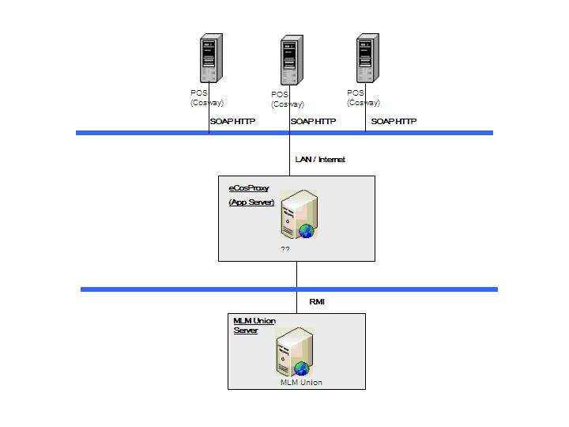

Looking from north bound perspective, eCosProxy System will be connected by Korea Cosway POS client application via SOAP HTTP Protocol.
Looking from south bound perspective, eCosProxy System will connect to MLM Union System via RMI Protocol.

Network Design
This section will describe the network design for eCosProxy System.

Server Details
Application Server:
Variable | Value
Hostname
IP
Username
Password

Firewall Rules - External System, Production Environment

# | From Host | Source  IP | To Host | Dest  IP | Protocol /  Port | TCP /  UDP | Description
1 | ISP |  |  |  | HTTP/80 | TCP | Public IP
2 | CWAPP | ?? | MLM Union | ?? | ?? | TCP | MLM Union

MLM Union Database Schema
Integration between eCosProxy with MLM Union is via JDBC connection by inject data into a database based on the schema provided by MLM Union.
MLM Union sales report program client module (deployed within member system infrastructure) will pick up the data record from database and send to MLM Union sales report program server for processing.
Below is the provided database schema from MLM Union:
- Table: T_RealMLM

Column | Data Type | Nullable | Remarks
SEQ | Integer | Yes | Primary Key.  Incremental value.
COMPANY_CODE | Varchar (4) | Yes | Company Code.  Value predefined in eCosProxy properties file.
JOBCODE | Varchar (2) | Yes | Code of the job. Possible value:  10 – Sales;  11 – Goods exchange;  12 – Goods Refund/Return;  13 – Delivery.  Value is pre-set by eCosProxy based on the called web service method.
STATE | Varchar (10) | Yes | State of the MLM company located.  Value is predefined in eCosProxy properties file. Default value: 00001000
ERRORCODE | Varchar (10) | Yes | Error code responded by MLM Union Sales Report Program of FAILED processed record.
ERRORMSG | Varchar (500) | Yes | Error message responded by MLM Union Sales Report Program in details describe the reason of failure.
GUARANTEE_NUM | Varchar(17) | Yes | Guarantee number responded by MLM Union Sales Report Program of SUCCESS processed record.
REGIDAY | Date | Yes | Creation Date of the record.
SEANDAY | Date | Yes | ??
RECVDAY | Date | Yes | Received Date by MLM Union.

- Table: T_RealMLM_SALES

Column | Data Type | Nullable | Remarks
SEQ | Integer | Yes | Foreign Key of T_REALMLM.
SALEORDER_NUM | Varchar (30) | Yes | Order Invoice Reference Number.  Input value by caller.
ORDER_TYPE | Varchar (10) | Yes | Order Type.  Input value by caller.
MEMBER_KIND | Varchar (1) | Yes | Member type. (“0” – Member; “1” – Customer)  Input value by caller.
MEMBER_NAME | Varchar (30) | Yes | Member Name.  Input value by caller.
MEMBER_NUM | Varchar (14) | Yes | Member Reference Number.  Input value by caller.
RESIDENT_NUM | Varchar(13) | Yes | Member Social Security Number.  Input value by caller.
TEL_NO | Varchar(20) | Yes | Member Telephone Number.  Input value by caller.
MOBILE_NO | Varchar(20) | Yes | Member Mobile Number.  Input value by caller.
POST_NO1 | Varchar(6) | Yes | Address area/zip code.  Input value by caller.
POST_ADDR1 | Varchar(120) | Yes | Address 1.  Input value by caller.
POST_ADDR2 | Varchar(120) | Yes | Address 2.  Input value by caller.
SALES_CARD | Numeric(12) | Yes | Payment by credit card.  Input value by caller.
SALES_CASH | Numeric(12) | Yes | Payment by cash.  Input value by caller.
SALES_SENDAMT | Numeric(12) | Yes | Payment by remitted into bank account.  Input value by caller.
SALES_DT | Varchar(8) | Yes | Sales/Invoice Date. Format: YYYYMMDD  Input value by caller.
OLD_ORDER_NUM | Varchar(30) | Yes | Order Reference number of refund/exchanged order. Only applicable for refund or goods exchange case.  Input value by caller.
OLD_ORDER_SEQ | Varchar(30) | Yes | Order Sequence number of refund/exchanged order. Only applicable for refund or goods exchange case.  Input value by caller.
DELIVERY_QUANTITY | Numeric(4) | Yes | Delivery quantity. Only applicable for delivery case.  Input value by caller.
DELIVERY_SEQ | Varchar(30) | Yes | Delivery sequence. Only applicable for delivery case.  Input value by caller.
DELIVERY_DT | Varchar(8) | Yes | Delivery Date. Only applicable for delivery case. Format: YYYYMMDD  Input value by caller.

- Table: T_RealMLM_SALES_LIST

Column | Data Type | Nullable | Remarks
SEQ | Integer | Yes | Foreign Key of T_REALMLM_SALES.  Relationship: 1-to-many
ORDER_SEQ | Varchar (30) | Yes | Item Order Reference Number.  Value input by caller.
GOODS_NAME | Varchar (80) | Yes | Item Product/Goods Name.  Value input by caller.
GOODS_COST | Numeric(8) | Yes | Unit Price of the item.  Value input by caller.
QUANTITY | Numeric (4) | Yes | Purchased item quantity.  Value input by caller.
OLD_ORDER_NUM | Varchar(30) | Yes | Order Reference number of refund/exchanged order. Only applicable for refund or goods exchange case.  Input value by caller.
OLD_ORDER_SEQ | Varchar(30) | Yes | Order Sequence number of refund/exchanged order. Only applicable for refund or goods exchange case.  Input value by caller.

