History – Base on USA requirement

- VIPs now have 2 Options for Joining

VIP Shoppers have 2 Choices for joining now:
- Pay $20 and get 30% off of any normal-priced products for one month up to a retail value of $200. (This does not include Rewards Items, Special Sets, or Promotion Sale Items)
- Buy $40 worth of normal-priced products on the first invoice, and get the VIP membership free.
Both options entitle the new VIP to a starter kit and 20 RP points.
In option A, the introducer of the VIP will receive DP on the retail value of the sale items (so if the VIP buys $200 worth of products, he or she pays only $140, but the introducer earns DP based on the $200 price.)
In option B, the introducer of the VIP will receive DP on the $40 purchase.

Existing VIP Shoppers will get 30% off of normal-priced products for one month during the month of August as a gift to keep them happy since the RP Pricing will disappear. They will also start to earn Direct Profit on the purchases of VIP Shoppers that they bring in (see section 2).

- Summary of DP, eV, RPs, and QUs after Aug 1, 2011

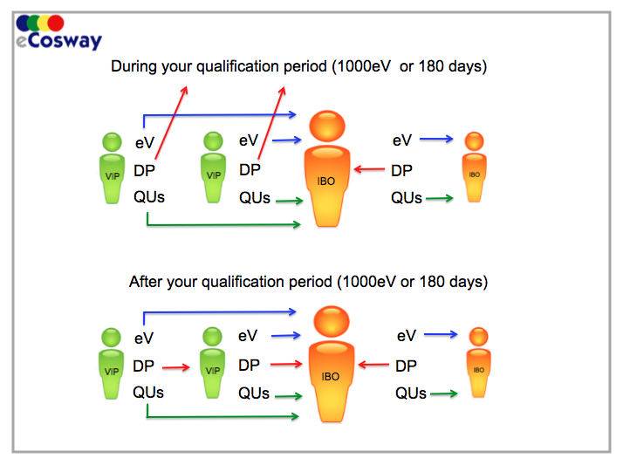

FAQs

Q. When VIP Shoppers pay $20 to join, they get 30% off of products for 30 days. Does this include Special Sets and Rewards Items?
A. No.

Q. Does a VIP Shopper that chooses the “buy $40 of products” route to join, still get 20 RPs?
A. Yes, the VIP Shopper will still get 20 RPs but will not get 30% off of products for 30 days like the VIP Shoppers who pay $20 will.

Web Service Flow

Member Registration

Member Cancel

Sales – Request Balance

Sales – Submit

Sales – Return

List of Status and Error Code from WebService
Status | Error | Description
0000 |  | SUCCESS; Successful processed by webservice
1010 |  | ERROR RECEIVED: Request failed validation process
 | 10101 | Insufficient parameter
 | 10102 | Record not exist
 | 10103 | Invalid parameter
 | 10104 | Invalid parameter length
 | 10105 | Service Unavailable
1200 |  | UNKNWON ERROR
 | 12001 | Unknown system error
5000 |  | Membership Status
 | 50001 | Member ID not exist
 | 50002 | Member ID exist
 | 50003 | Member ID exist without PIN
5010 |  | Membership Issue
 | 50101 | Invalid designated center
 | 50102 | Membership expired
 | 50103 | Incomplete membership
 | 50104 | Invalid or Wrong Pin
 | 50105 | Account has been locked, please customer service to assist.
6000 |  | Sales Error Code
 | 60101 | Sales Amount Not Tally
 | 60102 | Invalid Transaction

List of Transaction Type

Type | Description
00000 | General
10000 | Membership - General
10100 | Membership - Registration
10101 | Membership - Cancellation
10103 | Membership – Extend expiration date
10104 | Membership - Renewal
20000 | Discount – General
20100 | Discount – Adjustment (+)
20500 | Discount – Adjustment (-)
30000 | Sales – General
30100 | Sales – Adjustment (+)
30101 | Sales – Exchange / Return (+)
30500 | Sales – Adjustment (-)
30501 | Sales – Sales Invoice (-)

