General Rules of DP
- Taiwan server to maintain all the movement and calculation of the balance of Direct Profit.
- Online system to port over only the DP movement of VIP to Taiwan server, not for IBO as IBO’s ‘DP’ is treated as part of the profit and is to be maintained by online system.
 | Trx Type | Remark | Adjustment Type | Interaction Nature
1. | Utilize DP | Online sales utilize DP for payment | Downward | Real Time
2. | Earn DP | Profit calc how much DP the VIP earn | Upward | By Daily Batch
3. | Syst Adjust DP | Adj cause by sales return that utilized DP, system to auto-adjust back the DP to the purchaser after rtn | Upward | By Daily Batch
4. | VIP upgrade IBO | To notify TW server the upgrade date, TW server to based on the data to control 30days validity of DP after upgrade | NIL | By Daily Batch
5. | DP balance checking | To check the DP balance on hand | NIL | Real Time

- TW Server bases on the movement from online system to calculate the balance of the DP and the balance would not update back to online system.
- Whenever the flow requires checking on DP balance, online system to call Taiwan server and get the DP balance.
- Online system to create a link at Online Office which direct to Taiwan server for DP movement and balance checking purpose, statement of the DP movement & balance to be built on Taiwan server.
- Manual DP adjustment function is to be built on TW server for CSD and Oper Dept to perform the DP adjustment.
- Generally, the interaction of online system with TW server is to be categorized into 2 types:-
  - By Real time
  - By Batch

Real Time Movement
Online system to call TW server to update/request balance and to receive the TW server response immediately.
- Online system to request for DP balance
- To create a function at Online Office(in My Profile) & Control Center to check the balance of DP
- Secret password required when the VIP check the DP balance
- Once the secret password is validated by online system, online system to direct the page to DP statement that built on TW server
- Parameters to pass to TW server for DP balance/statement checking [To be filled up by Chooi Mey]

- Online sales to utilize DP amt for payment
- Introduce a new payment mode ‘Direct Profit’
- When user select to user DP payment mode and click on ‘Proceed’ button at the Payment selection page, online system initiate the API calling to TW server by passing over the parameters stated below
1. | MEMBER ID
2. | COUNTRY CODE of shopping mall
3. | TRX REF NO

- TW server to check if ID and country code matched with details maintained at TW server
- YES -> Return DP amt on hand
- NO -> Return status to notify online system DP cannot be used
- Online system based on the DP amt returned from TW server to check if is sufficient to cover the payment (inclusive of tax & freight charge).
- Purchaser cannot key in the amt of DP to use. System always force to settle full payment. They only allow to choose ‘To Use’ or ‘Not to use’.
- After getting the positive response from TW server:-
- If the amt is sufficient to cover the full payment, system to send confirmation with the amt to be deducted from DP balance to the TW server and proceed to print receipt.
- If the DP amt is insufficient , the remaining balance is to be reflected on the payment selection page and user can use other payment type (Eg. Credit Card, eAcc) to cover the balance (split payment)
- System does not need to wait for notification from TW server if the DP deducted successfully before proceed to printing receipt as all trx are assumed to be successful.
- If is partial payment that involve DP+credit card /Debit card, system to send out the deduct dp notification only after has confirmed the credit card/ debit card charged successfully from payment gateway.
- For regen-order that involves DP partial payment, Finance Dept would always assume that the DP amt has already being deducted successfully (same practice with eAcc partial payment practice)

- When there’s confirmation on trx using DP as payment mode, a record would be inserted into ‘DP_INTERFACE’ table (table name subject to be change).
- This table keeps track the response from TW server for the respective trx
- Status of DP successfully deducted at TW server
- Status of ineligibility of purchaser to utilize DP
- There’s a daily batch to check and re-send the trx that’s pending for TW status update to TW server. TW server to double-check if the deduction of DP for these trx has been attended.

Activity Diagram of Mall Online Sales:
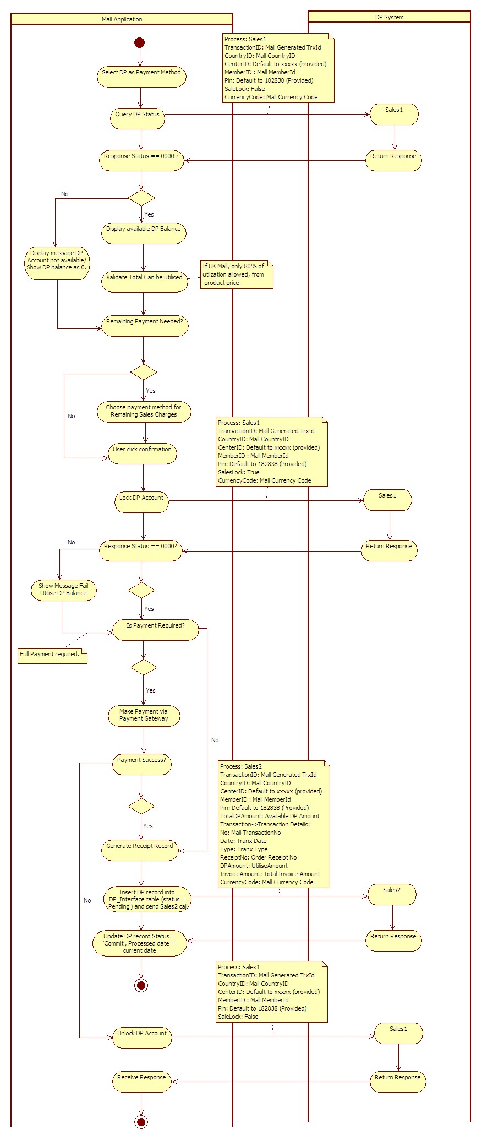
Activity Diagram of Daily Reconciliation Batch:
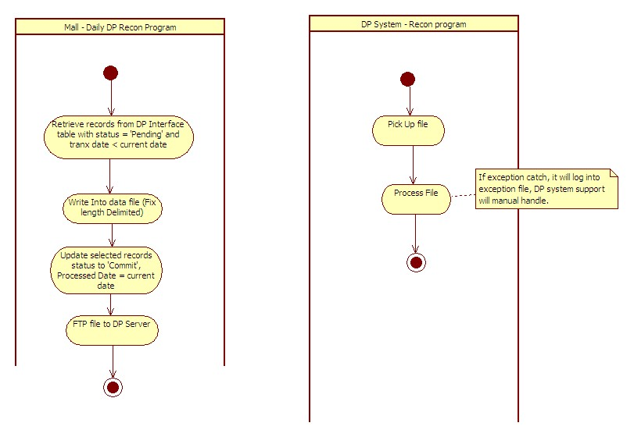
Batch to update online DP trx to TW server
- There is a daily batch to update certain type of online DP movement to TW server

- To have a log to keep track the batch processing status

